1. 
2. This is deprecated as spring security wants us to use in any app which have sensitive data.
3. 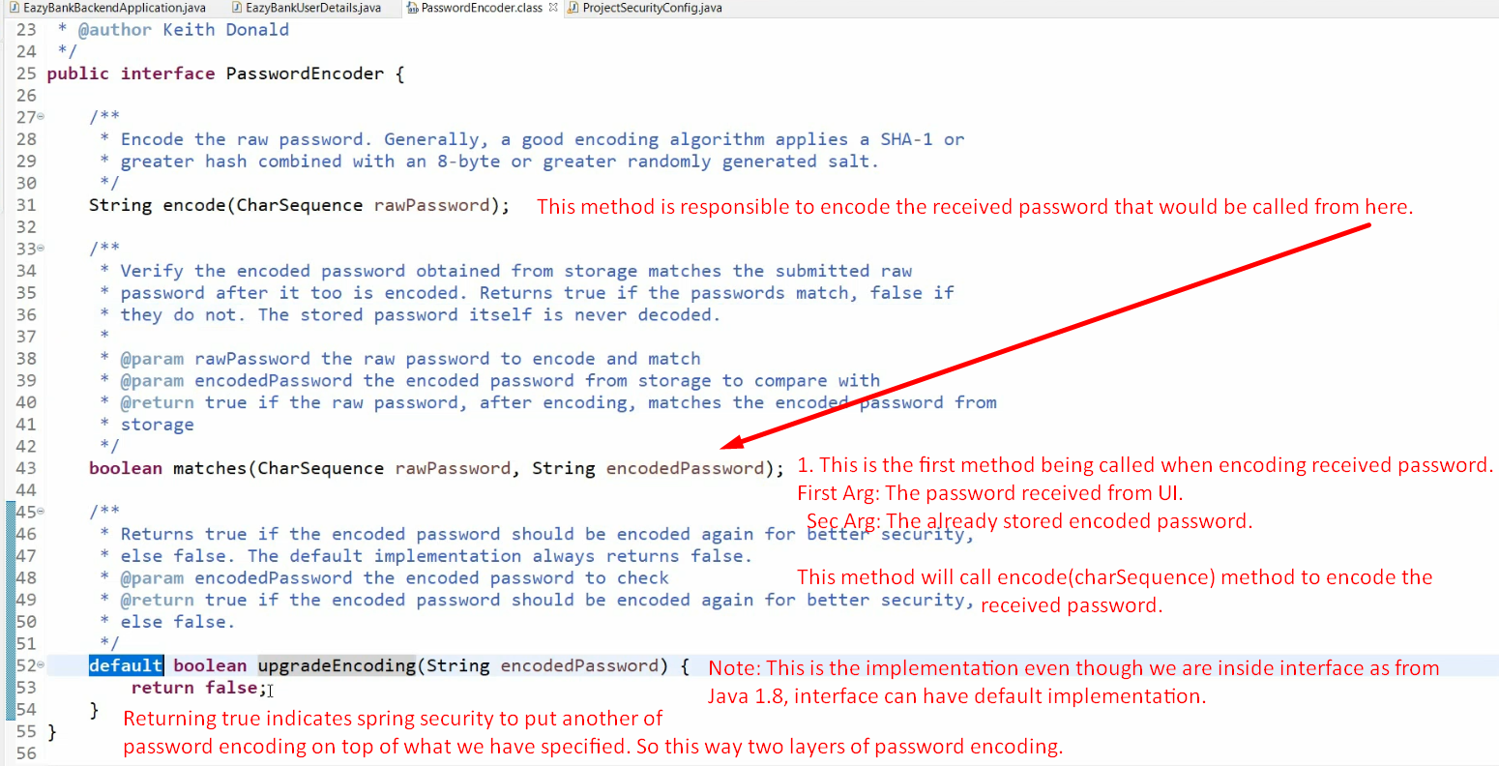
4. 